**INTRODUCTION**

* Site manager is a simple system software that manages billboards and masts and faces a company operates and manages within the country, county Towns and cities
* Its records the number of bill boards that are erected in a particular plot of land for a given landlord
* It records the Details of landlords and there contract with the company
* Generate reports for payments for a given period of time or a selected sites e.t.c

Fig1. General view of site manager system

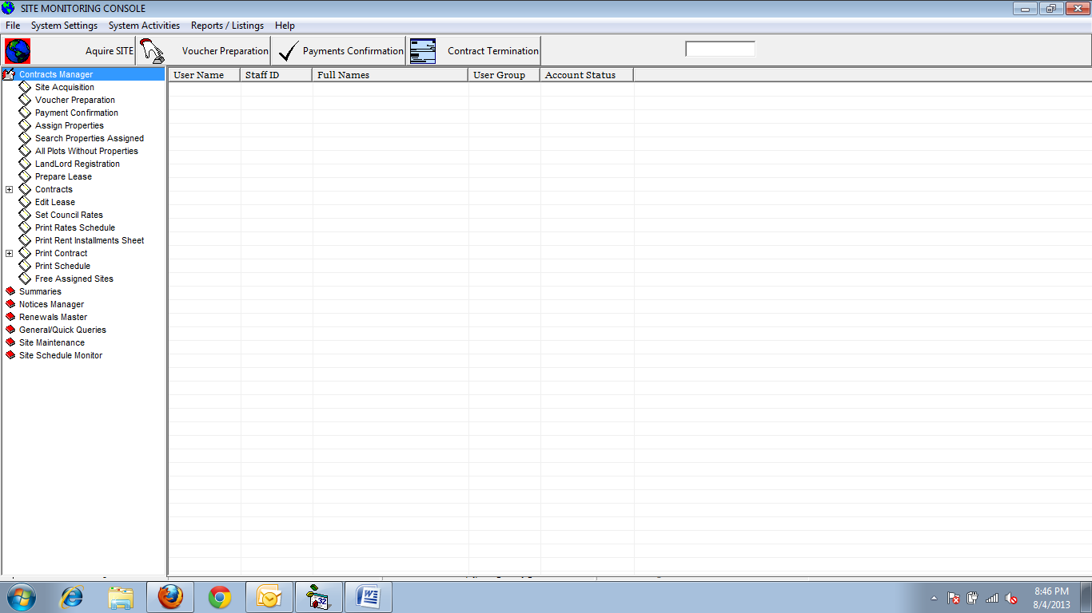

Start the Program Click on Site manger Icon

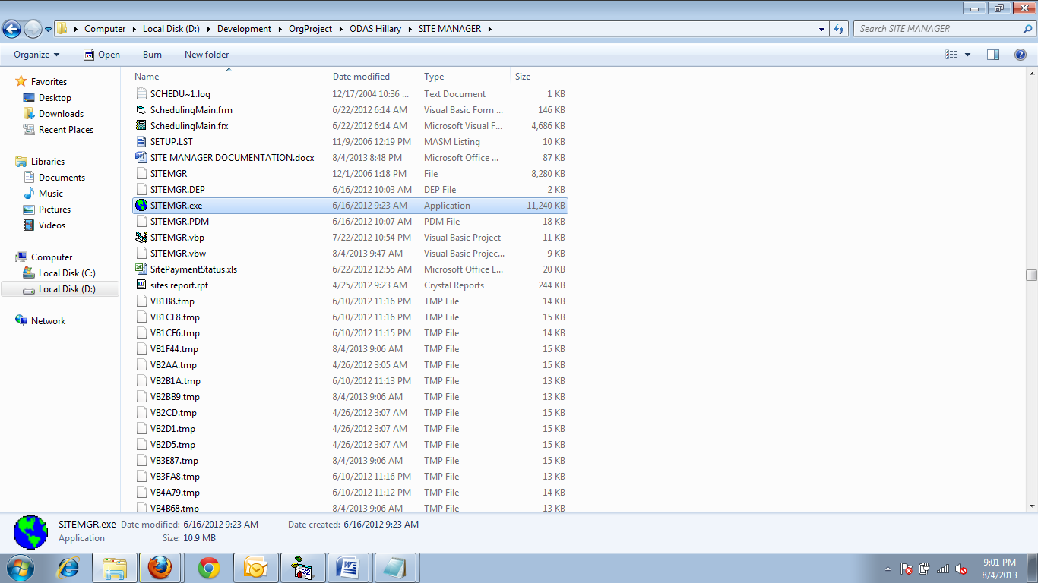

Pass word in the password Prompt page

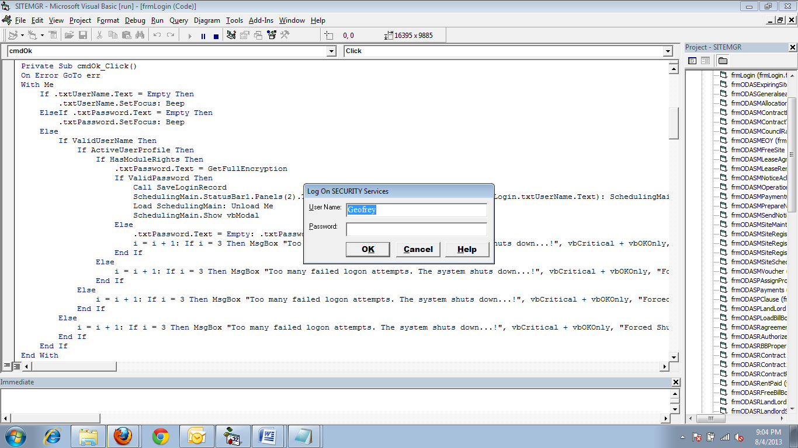

Click ok after Filling the password and username

The main page will appear as shown below

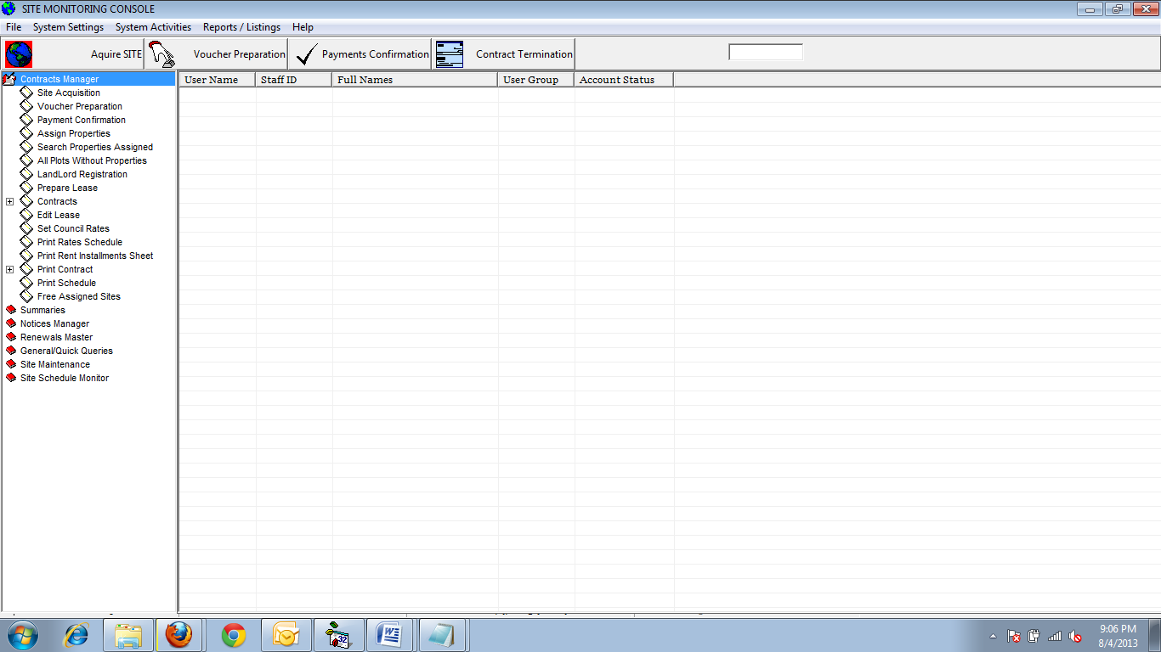

**LANDLORD REGISTRATION**

* Click On system Setup Menu – Select Landlord Registration
* Click new record
* Fill in the Landlord Details then
* Click Save

Editing Landlord Details

* Click on Search
* Select on existing record
* Then click Edit
* The make changes
* Then Click on Save changes

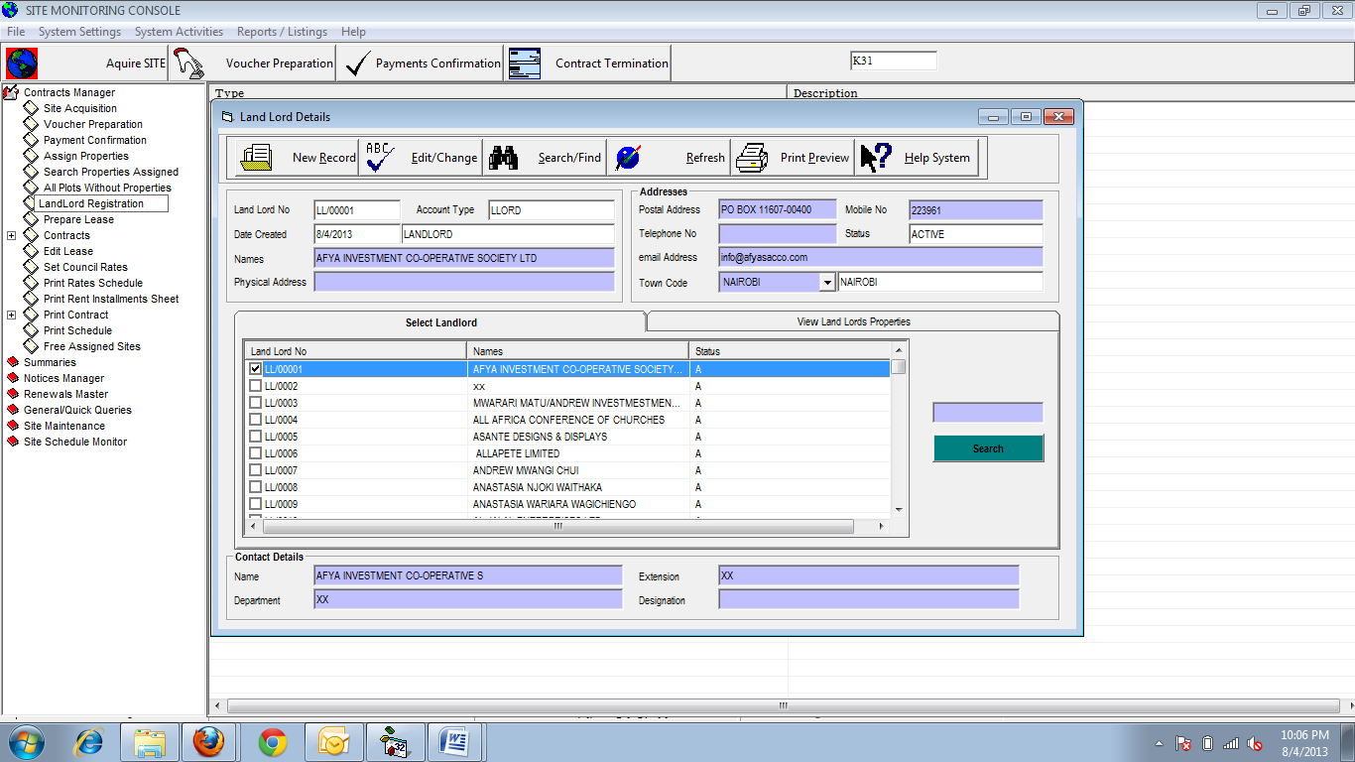

**SITE REGISTRATION**

* Click on systems Settings
* Select site Registration
* Click New Record
* Fill in the Site registration Details
* Click Save Record

Editing a record

* Click Search, Enter the plot Number
* Click Edit
* Make changes to the Records
* The Click Save Changes

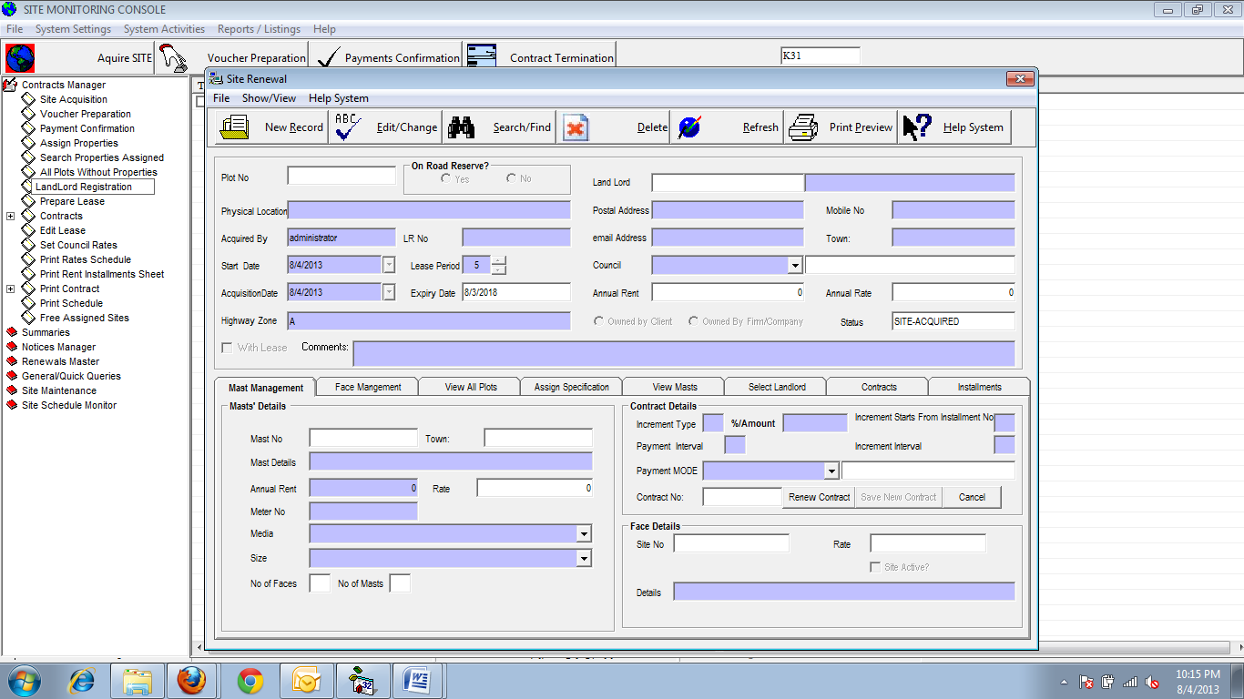

**Acquire A site**

* To acquire a site click on Acquire a site Button or menu then Select the town or location as shown.

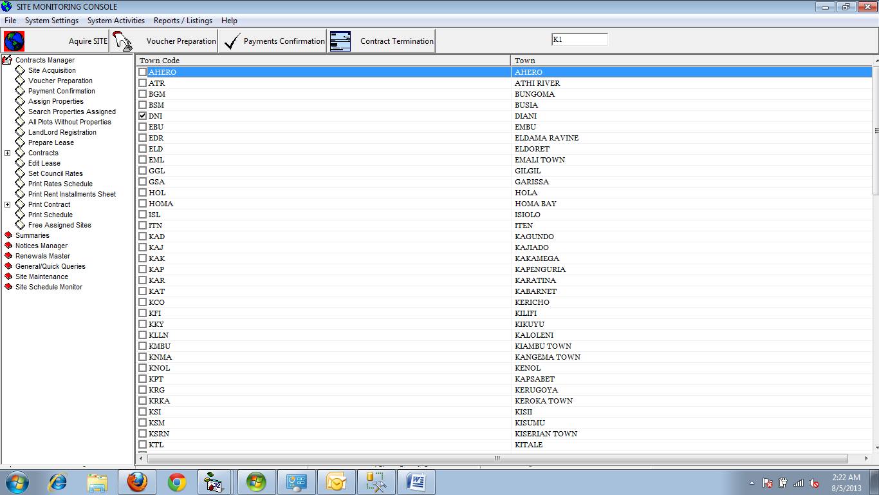

List of Locations

Select the location as shown on the Picture above

On select you will see the window below: